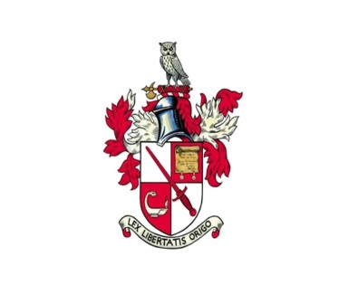

City of London Solicitors’ Company

Press Release

The City of London Solicitors’ Company held its Annual Banquet at Mansion House last night (22nd March 2018). Two hundred and twenty members and their guests dined in the magnificent surroundings of the Egyptian Hall, hosted by Alderman Dame Fiona Woolf representing the Lord Mayor and Alderman David Graves, the Master of the Company.
After dinner the guest speaker, Lord Neuberger of Abbotsbury, spoke about his career in the law and his role as a judge and former President of the Supreme Court. He also mentioned his recently launched initiative “Access 2 Lawyers” aimed at encouraging every judge and lawyer throughout the country to visit a state school or sixth form college at least once a year to talk to pupils about the law and a career in the law.

Ends

Notes to editors
Contacts:
City of London Solicitors’ Company 020 7329 2173 or mail@citysolicitors.org.uk
More details about Access 2 Lawyers can be found at https://www.facebook.com/Access-2-Lawyers-146414142741690

